- Home |

The Parallels Between Space Missions And COVID-19 Isolation
- By Keith Cowing
- Posted March 21, 2020 9:04 PM
- 0 Comments
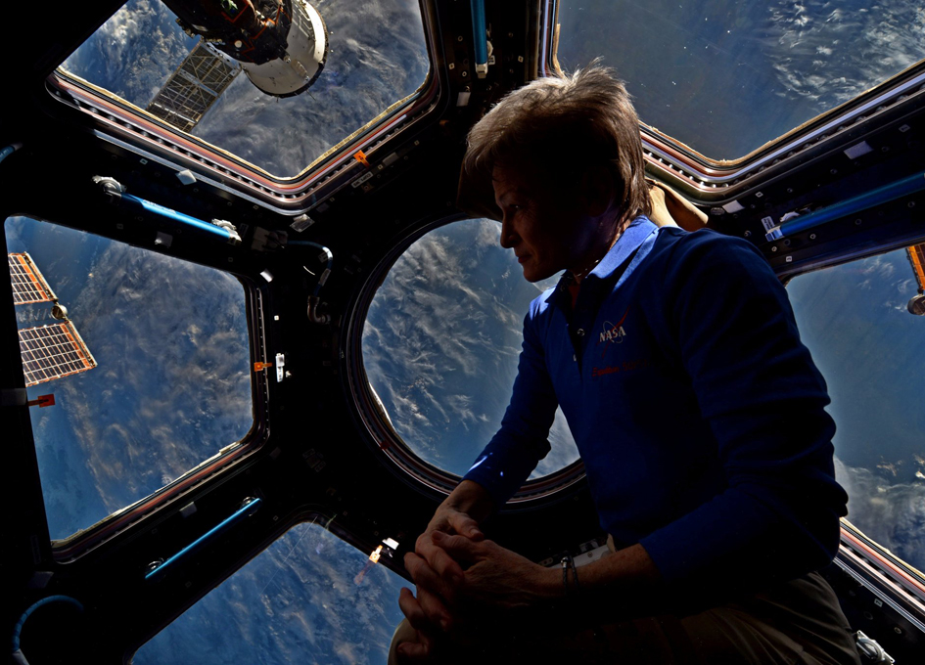
Peggy Whitson @AstroPeggy "638 days in space and the view is still amazing! Soaking up some sunset time in the cupola."
Jack Stuster has been conducting studies for NASA on how crews live and work in space and the parallels that can be found with expeditions on Earth for decades. He has provided this commentary about confinement and isolation during the COVID-19 pandemic and the parallels within his studies.
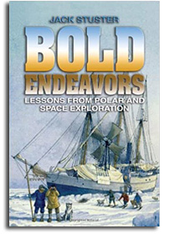
Keith's note: If you are interested in further insight into what Jack's research you must check out his book "Bold Endeavors: Lessons from Polar and Space Exploration". I took my copy to Everest Base Camp with me in 2009. Astronauts asked for a digital version of the book several years ago for the ISS library and before that, astronaut Jim Voss took copies of the the books's recommendations in his crew notebook. You can buy the book on Amazon here.
------
Dear Keith:
I have been asked recently by two German journalists for suggestions about how families and others might adapt to confinement and isolation in their homes in response to the current pandemic. As you know, I have studied conditions analogous to space stations and to expeditions to the Moon and Mars for nearly 40 years, and I studied life on the ISS during the 13-year Journals Flight Experiment. I have described the research in articles/papers, NASA technical reports, and a book, Bold Endeavors: Lessons from Polar and Space Exploration. I am offering the recommendations, below, and on the attached one-page document in hope that the information might be useful to your readers.
My primary recommendation is for people to view the self-quarantine as an opportunity, rather than an obstacle. Polar explorers knew from the experiences of whalers and sealers that boredom would be their main enemy when beset in the ice, so they always were prepared with meaningful work to perform. People "beset" in their homes can work on projects that have been delayed because there never is time (painting, gardening, repairing); make it a group activity, if possible. We all should view our confinement as an opportunity to read, perhaps to read that book for which one never has time. Historical novels are particularly appropriate because a good one can transport the reader far from our current troubles. For example, I am re-reading Patrick O'Brian's Aubrey/Maturin series about the British Navy during the age of sail. Imposed confinement also provides an opportunity to start that short story, screenplay, or novel one has intended to write. And, you can keep a journal of your experiences and observations; ISS astronauts have reported that making periodic entries in a confidential journal helps them endure long-duration isolation and confinement.
Families can play card and board games together, but they probably should avoid Monopoly and Risk; Risk, in particular, caused such divisiveness during a military simulation that I directed in 1989 that the group banished the game. Individuals also can play chess with a friend remotely, like ISS astronauts have done, communicating moves via email. Confinement provides an opportunity to call friends/family on the telephone and to talk for as long as you want; it also allows you to check on the behavioral and physical health of loved ones.
Most important, eat at least one meal together with family or roommates each day--maybe even prepare the meal together. And, consider having special meals to commemorate events, which adds novelty and helps mark the passage of time (e.g., birthdays, anniversaries, birthdays and anniversaries of famous people, every Saturday, at the expected mid-point of the confinement, etc.). Nansen's crew turned to their almanac for suggestions when they exhausted the list of birthdays and Norwegian holidays.
All of these suggestions, and those listed on the attached document, have been used by explorers in the past to help endure their periods of isolation and confinement. And, as my favorite explorer, Fridtjof Nansen, once said, "We are all really explorers, each one seeking our own path through life."
Lessons for Group or Family Confinement Derived from ISS and Space-Analog Experiences
Jack Stuster, PhD, CPE
Santa Barbara, California
jstuster - at - anacapasciences.com
Group actions/attitudes that foster adjustment and solidarity:
- Set getting along as your highest goal.
- Set a schedule, but it is OK to sleep in; sleep is good.
- Eat meals together (dinner--especially important for families).
- Conduct group leisure activities (e.g., card or board games, movie nights).
- Respect others' need for privacy/personal space (periodic withdrawal from group); however,
- Monitor and be sensitive to the mental states of others (e.g., to avoid cocooning) and then act decisively to maintain relationships and behavioral health when necessary.
Specific individual behaviors that foster adjustment and group solidarity:
- Be polite and respectful.
- Avoid controversial subjects.
- Do not engage in derisive humor.
- Do more than your share of communal tasks.
- Consider the possible consequences before you say or do anything.
- Consciously attempt to be cheerful and supportive of your teammates.
- Be considerate; more than that, try to avoid being annoying in any way.
- Make a list of tasks to perform during confinement; crossing off accomplishments provides tangible results and helps mark the passage of time.
And, little things, such as:
- Don't leave your items laying around.
- Clean up after using galley, lavatory, common areas, or workspace.
- Return items to shelves and drawers with the labels facing outward.
- Replace empty toilet paper rolls and put the seat down after using the toilet (men).
Characteristics of esteemed leaders and teammates in Antarctica (in order of importance):
- Social compatibility (affability);
- Emotional control (stability);
- Performance (proficiency).
Personal qualities/social abilities needed by Mars expedition crew (in order of importance):¹
- Confidence
- Patience
- Teamwork
- Emotional Control
- Affability
- Tolerance

